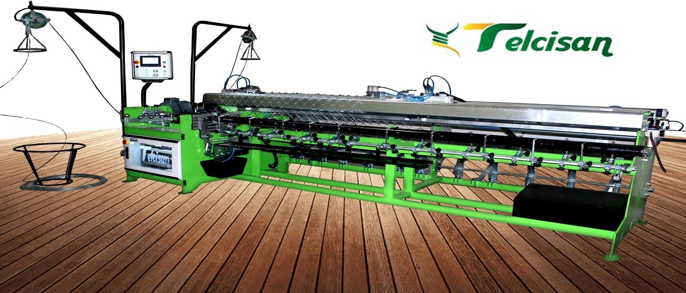

Machine type Weaving width

Wire mesh diameter (GALVANIZED) Wire mesh diameter (PVS)

Opening intervals Controlling system Total power Machine weight

Machine dimensions Capacity/hour

Resistance value of wire mesh Pattern number (Optional)

***WIRE FENCING MACHINE TLS 300-X***

# (TLS 300-X)

20 – 320 cm

1.8 – 4 mm

2.9 – 4.5 mm

40x40 – 85x85 mm PLC

8 KW

1750 Kg

Height: 250 cm

Width: 200 cm

Length: 480 cm

120 – 160 M2

450 – 500 Nw/mm2

3 types

RULO SİSTEM

Price (Exworks)

# NORMAL + COMPACT SİSTEM

19.000 USD



* **Width and length dimensions are entered via touch screen. At the end of the work, the machine stops and gives alarm.**
* **In case of wire intertwining, there are 3 different stop systems.**
* **With the electronic cycle adjustment button, it works at the required speed.**
* **It is adjusted easily with the manual, semi-manual and automatic options.**
* **Double sided twist can be added.**
* **Minimum weaving width is 20 cm.**
* **A system developed for changing the pattern practically and using it easily.**
* **Electric power 380V.**
* **Ability to work nonstop for 24 hour.**
* **Thanks to internet connection, ability of remote access, updating and trouble shooting.**
* **It has double-entry system.**
* **Delivery Time: 25 Work days After Advance**
* **Payment: 50% Prepayment, 50% Before Loading (Via Bank Transfer)**
* **GUARANTEE: (3) years excluding user errors.**

Note: As the equipment necessary for the machine use, a 200 lt /8 bar air compressor is needed

